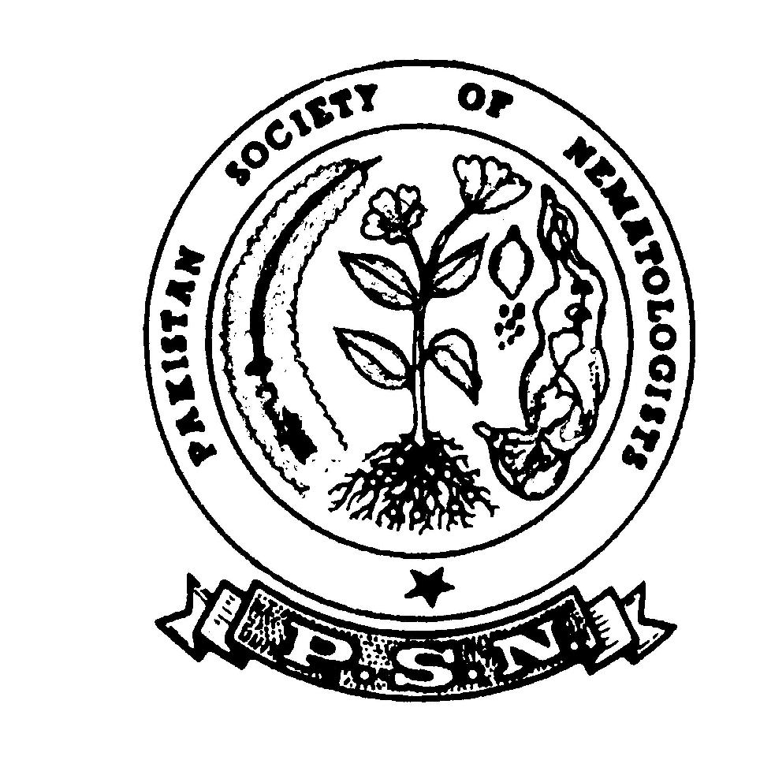
Pakistan Society of Nematologists

APPLICATION FOR MEMBERSHIP

I, ______________________________________________ apply for the membership to the Pakistan Society of Nematologists. Membership fee for the year __________ is sent herewith.

NAME ________________________________________________________________________________

OCCUPATION ________________________________________________________________________

OFFICIAL ADDRESS __________________________________________________________________

DEGREE _____________________________________________________________________________

INSTITUTION (Name & Location) _______________________________________________________

PERMANENT ADDRESS _______________________________________________________________

EMAIL ADDRESS

AREA OF SPECIALIZATION (In brief) ___________________________________________________

Date ____________________ |  |  | __________________
MEMBERSHIP FEES: |  |  | (SIGNATURE)
Member……………. One year Rs. | 1000/- US$ | 70.00
Student Member……One year Rs. | 500/- US$ | 40.00
Life Member……………….…. Rs. | 5,000/- US$ | 400.00
Corporate Member (one year) Rs. 10,000/- US$ |  | 1000.00

- Any change in the above information which you would like to be included in the Directory should be reported to the Secretary/Treasurer not later than December, every year.

- Student members should forward recommendation letter from their Professor.
- Payment should be made in the name of “Pakistan Society of Nematologists” and sent to the General Secretary/Treasurer. Subscription money can be paid directly via swift wire transfer system into the following account of the society:

Swift NBP-APKKA-666

Account Number: 182-8
National Bank of Pakistan (NBP)
University of Karachi Branch, Branch Code: 071 Karachi, Pakistan
OR
Through Bank Draft drawn on National Bank of Pakistan (NBP), University of Karachi Branch, Karachi, Pakistan in favour of PSN, Account No. 182-8.

All inquiries and payments should be made to:

Dr. Saboohi Raza

General Secretary / Treasurer,
Pakistan Society of Nematologists,
National Nematological Research Centre, University of Karachi, Karachi-75270, Pakistan.
Phone: 0092-21-99261387
Email: shahinafayyaz@gmail.com
nnrcku@gmail.com

